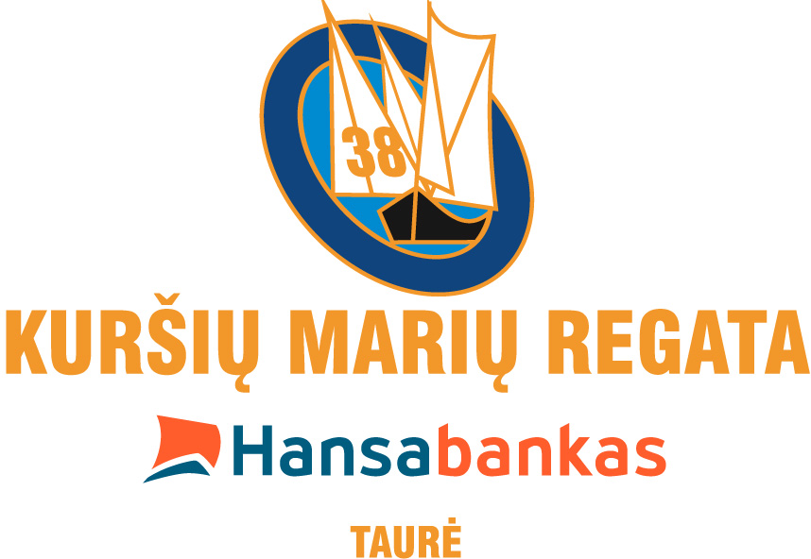

Programme

30 July

19:00 The line of Yacht crews at Klaipėda yacht club. Regatta flag hoist up.
21:00 Regatta flag lower.

31 July

9:00 Regatta flag hoist up.
10:00 Judges and yacht captains counsel.
11:00 1st stage start.
1st & 2nd starting groups: Klaipėda yacht club, priėmimo boja, Palanga, priėmimo boja, Klaipėda yacht club.
3rd starting group: Klaipėda yacht club, Palanga, Klaipėda yacht club.
21:00 Regatta flag lower.

1st August

9:00 Regatta flag hoist up.
10:00 2nd stage start.
1st & 2nd starting groups: Klaipėda, Nida, Ventės ragas, Lesnoje, Polesk, Nida.
3rd starting group: Klaipėda, Nida, Ventės ragas, Lesnoje, Nida.
21:00 Regatta flag lower.

2nd August

9:00 Regatta flag hoist up.
19:00 Yachts crews march-past and Regatta opening festival at Nida.
1st & 2nd stage starts the 1st and 2nd stage-winners awards. The concert at Nida bund.
21:00 Regatta flag lower.
21:05 The movie „ The Curonian Gulf Regatta – 50 years“.
Regatta diary.

3rd August

9:00 Regatta flag hoist up.
10:00 3rd stage start.
1st & 2nd starting groups: Nida, Golovkino, Ventės ragas, Nida.
3rd starting group: Nida, Bulvikio rago boja, Pervalka, Ventės ragas, Nida, drowned barge, Nida.
20:00 3rd stage-winners awards.
ALITA COGNAC presentation at Nida bund.
21:00 Regatta flag lower.
Regatta diary.

4 August

9:00 Regatta flag hoist up.
10:00 4th stage start.
1st & 2nd starting groups: Nida, Rybačij, Ventės ragas, Nida, drowned barge, Nida.
3rd starting group: Nida, Rybačij, frontier, Nida.
20:00 4th stage-winners awards.
ALITA GERA (Grapefruit) presentation.
21:00 Regatta flag lower.
Regatta diary.

5 August

9:00 Regatta flag hoist up.
11:00 The Public regatta.
14:00 The Journalists regatta.
16:00 TOP CAT catamaran race
16:30 „Optimist“ regatta cup winners awards.
17:00 Captains race on „Optimist“.
20:00 The concert at Nida bund.
21:00 Regatta flag lower.
The movie „LBS – 70 years“.

6 August

9:00 Regatta flag hoist up.
9:30 5th stage start. The Olympian distance beside Nida.
14:00 „Match race“.
17:30 Cutter race.
20:00 5th stage-winners awards.
20:30 Regatta winners awards, regatta closure party, concert.
21:00 Regatta flag lower.
24:00 Firecracker.

